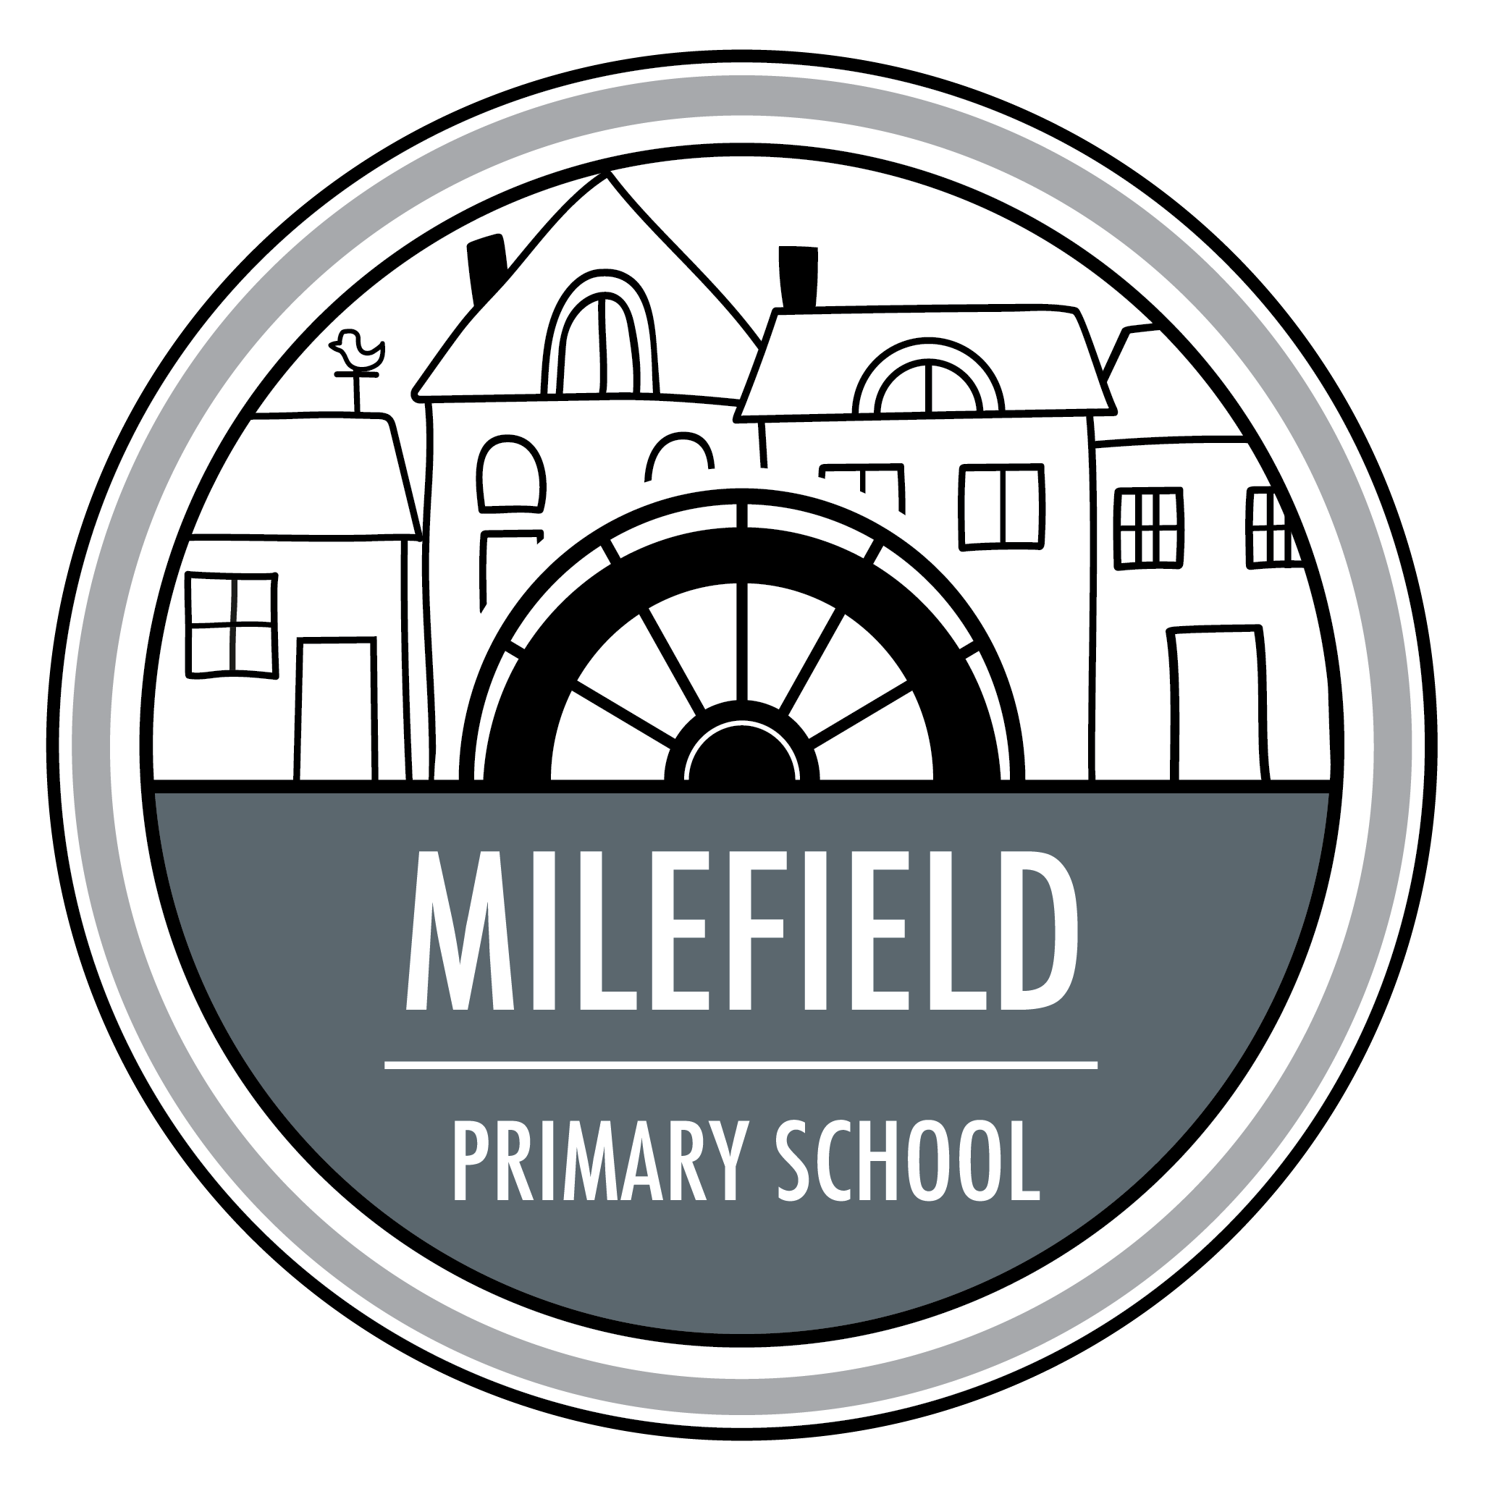
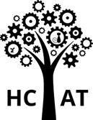
Milefield Primary School
Approach to teaching of
PD & RSHE

The delivery of the PD & RSHE curriculum is taught following the guidelines provided by the DfE alongside the PD & RSHE Association.
At Milefield Primary School, we are passionately committed to providing our pupils with the best possible start in life. We are driven to ensure that we support pupils' spiritual, moral, cultural, mental and physical development and help them to become a resilient responsible and happy individual that will allow them to be able to adapt to the changing world in which we live in. Through teaching PD & RSHE, our pupils gain vital understanding of the world around them and learn how to thrive as individuals, family members and members of society. We believe that all children deserve to succeed and our ultimate goal is to have nurture-articulate, well informed children and to help them prepare for life’s many opportunities and challenges.
Our Aims:
- To deliver a relevant and ambitious curriculum that supports our pupils to understand the world around them.
- To provide an inclusive/safe environment that equips all children, including those with special educational needs and/or disabilities, to unlock their full potential.
- To foster inquisitive minds, providing opportunities for all children to question, choose, evaluate and argue rationally.
- To adequately prepare children for the next stage of their educational journey.
- To maintain high expectations of our pupils’ behaviour and attitudes towards learning in school.
- To establish and maintain positive relationships between everybody in our school community including pupils, staff and parents.
- To maintain a culture of mutual respect and co-operation.
Scheme of work:
We have adopted 3 core themes with specified topic areas:
Health and Wellbeing | Relationships | Living in the wider world
- Mental Health  - Keeping Safe  - Healthy Lifestyles  - Ourselves, Growing and Changing  - Drugs, Alcohol and Tobacco | - Respecting Self and others  - Friendships  - Managing Hurtful Behaviour and Bullying  - Families and Close Positive Relationships  - Safe Relationships | - Shared Responsibilities  - Communities  - Media Literacy and Digital Resilience  - Economic Wellbeing: Aspirations, Work, Career  - Economic Wellbeing: Money
Overarching concepts developed through the Programme of Study:
- Identity (their personal qualities, attitudes, skills, attributes and achievements and privacy, including online)
- Relationships (including different types and in different settings, including online)
- A Healthy (including physically, emotionally and socially), balanced lifestyle (including within relationships, work-life, exercise and rest, spending and saving and lifestyle choices)
- Risk (identification, assessment and how to manage risk, rather than simply the avoidance of risk of self and others) and safety (including behaviour and strategies to employ in different settings, including online and in an increasingly connected world)
- Diversity and equality (in all it’s forms, with due regard to the protected characteristics set out in the Equality Act 2010)
- Rights (including the notion of universal human rights), responsibilities (including fairness and justice) and consent (in different contexts)
- Change (as something to be managed) and resilience (the skills, strategies and ‘inner resources’ we can draw on when faced with challenging change or circumstance)
- Power (how it is used and encountered in a variety of contexts including online; how it manifests through behaviors’ including bullying, persuasion, coercion and how it can be challenged or managed through negotiation and ‘win-win’ outcomes)
- Career (including enterprise, employability and economic understanding)
These will provide a relevant context for pupils to both broaden and deepen their understanding of the key concepts and to develop competence in the essential skills. It is important that out pupils can see how the skills acquired through looking at one issue can be transferrable to other contexts. Our world is rapidly changing and whilst the content of PD &RSHE is vitally important, it can quickly date and we cannot predict the challenges, opportunities and responsibilities that pupils may face in their future.
It is the overarching concepts and essential skills that will enable pupils to manage the challenges, opportunities and responsibilities they will now face in their future.

Intent
The focus of PD & RSHE is teaching the fundamental building blocks and characteristics of positive relationships, with particular reference to friendships, family relationships, and relationships with other children and with adults.
This starts with pupils being taught about what a relationship is, what friendship is, what family means and who the people are who can support them. From the beginning of school, building on early education, pupils are taught how to take turns, how to treat each other with kindness, consideration and respect, the importance of honesty and truthfulness, permission seeking and giving, and the concept of personal privacy.
Establishing personal space and boundaries, showing respect and understanding the differences between appropriate and inappropriate or unsafe physical, and other, contact – these are the forerunners of teaching about consent, which takes place at secondary.
Respect for others is taught in age-appropriate ways, in terms of understanding one’s own and others’ boundaries in play, in negotiations about space, toys, books, resources and so on.
From the beginning, teachers talk explicitly about the features of healthy friendships, family relationships and other relationships which young children are likely to encounter. Drawing attention to these in a range of contexts should enable pupils to form a strong early understanding of the features of relationships that are likely to lead to happiness and security. This will also help them to recognise any less positive relationships when they encounter them.
The principles of positive relationships also apply online especially as many children will already be using the internet. When teaching relationships content, teachers will address online safety and appropriate behaviour in a way that is relevant to pupils’ lives. Teachers include content on how information and data is shared and used in all contexts, including online.
We understand that teaching about families requires sensitive and well-judged teaching based on knowledge of pupils and their circumstances. Care is taken to ensure that there is no stigmatisation of children based on their home circumstances and needs. Time is planned in to reflect sensitively that some children may have a different structure of support around them; for example, looked after children or young carers.
Alongside understanding the importance of self-respect and self-worth, pupils are supported to develop personal attributes including honesty, integrity, courage, humility, kindness, generosity, trustworthiness and a sense of justice.
Relationships Education also creates an opportunity to enable pupils to be taught about positive emotional and mental wellbeing, including how friendships can support mental wellbeing.
The HCAT progressive documents support the progression of knowledge and skills a child should learn and how these are built upon over time.

Implementation
The Accelerated Learning Cycle, based on the work of Alastair Smith, is applied in all lessons. It stems from the idea of a supportive and challenging learning environment. The cycle has active engagement through multi-sensory learning, encourages the demonstrating understanding of learning in a variety of ways and the consolidation of knowing.
The curriculum documents for science also includes subject content in related areas, such as the main external body parts, the human body as it grows from birth to old age (including puberty) and reproduction in some plants and animals. At WGPS we cover this additional content on sex education to meet the needs of our pupils, even though this is not a statutory requirement.
It is important that the transition phase before moving to secondary school supports pupils’ ongoing emotional and physical development effectively. Therefore, HCAT have developed a bespoke sex education programme tailored to the age and the physical and emotional maturity of our pupils. It aims to ensure that both boys and girls are prepared for the changes that adolescence brings and – drawing on knowledge of the human life cycle set out in the curriculum for science - how a baby is conceived and born.
The Relationships Education, RSE, and Health Education (England) Regulations 2019 have made Relationships Education compulsory in all primary schools. However, sex education is not compulsory in primary schools and the content set out in this guidance which chooses to teach aspects of sex education (which go beyond the national curriculum for science), is in-line with our schools’ policies and all our schools have individually consulted with parents on what is to be covered.

Impact
RSE is largely assessed formatively by the class teacher. By knowing the class well and establishing ground rules early on, the class teacher creates close, positive relationships with the children in which they are able to assess the understanding of the children during each topic. As our lessons are mainly discussion based, reflection questions are completed after a lesson to show progress throughout KS1 and KS2. Teachers will provide written and verbal feedback based on reflections of the children to challenge their thinking and extend them further. In Early Years Foundation Stage, we assess children’s knowledge and understanding according to the relevant aspects of the Development Matters. The information gathered will inform subsequent teaching and learning.
As a school, we believe that reflection time is an important step in pupil learning and progress. We ensure that our pupils are given time to reflect upon their learning. Reflection helps us to recognise what and how we have learned and what we need to focus on in the future. Reflection should be about valuing and encouraging pupil involvement – getting them to share ideas, listen to each other and develop the confidence to join in.

Adaptations

At MFPS our curriculum is ambitious for all pupils, including those children with SEND. Curriculum designers and teachers have high expectations of what SEND pupils can achieve and the curriculum is not diluted or unnecessarily reduced for SEND pupils. Every pupil is different and so what works for each pupil varies. Pupil’s individual needs are carefully considered and adaptations are planned to ensure the success of pupils. The way that our curriculum is designed ensures that chunks of learning are sequenced in a coherent way to enable all pupils, including those with SEND, to build on prior knowledge.
Cognitive overload can be a barrier to learning which is one of the reason why we have chosen half termly curriculum drivers.
Where pupils are identified with having complex needs it may be appropriate to provide a personalised curriculum which will be based on individual needs and will retain ambition for the pupil. Where working memory is an issue for pupils, including those with SEND, we look to reduce extraneous load as much as possible as well as identifying key information when teaching. Adaptations to support individual pupils will be recorded on personal school support plans.
At MFPS we do not assume that pupils with SEND learn content better through practical work as this can cause distraction and cognitive overload rather than increase clarity or accessibility. The curriculum is not narrowed for any pupils. Knowledge is taught and then pupils are provided with opportunities for scientific enquiry to test and investigate the knowledge taught. Pupils’ specific needs determine the types of adaptations which are required. These adaptations are in how the subject is taught rather than the content pupils are expected to learn. Where appropriate, learning will be chunked into smaller steps and pre learning and consolidation time in planned in to support need. Time is also planned to ensure pupils with SEND are pre taught vocabulary to support their understanding. Adaptations may include supporting pupils to pay attention to key aspects as well as reducing excessive or unhelpful demands on working memory.
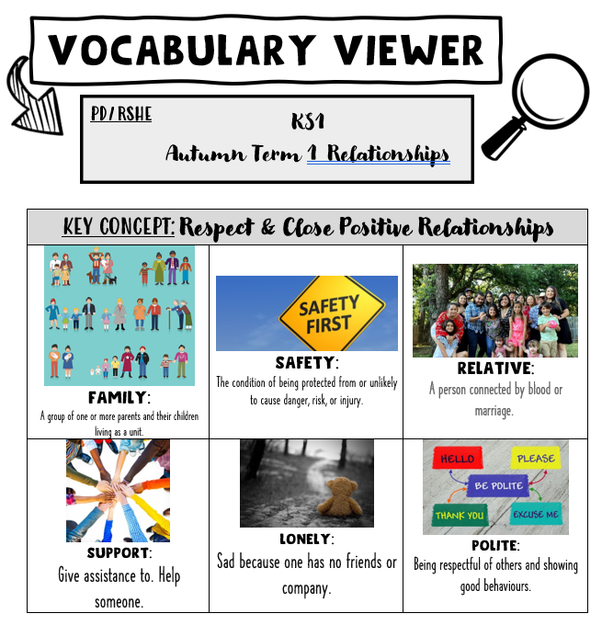
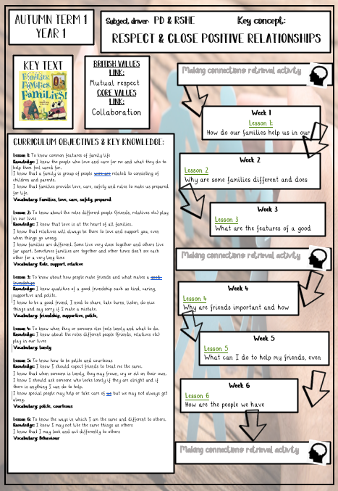
Example knowledge organiser Example Vocabulary viewer

